**CRICKET LIVE SCORE MANAGEMENT SYSTEM**

A project work submitted to VHNSN College (Autonomous)

In partial fulfillment for the award of the

Degree of Bachelor of Computer Applications

Project work undertaken at

MCA Computer Centre,

Department of Computer Applications,

VHNSN College (Autonomous),

**A PROJECT REPORT**

Submitted by

**DINESH G**

Reg. No: 20SUCA023

Under the Guidance of

**Mrs. A. MAREESWARI, M.C.A, M.Phil., P.G.D.C.A., P.G.D.A.OR.,**

Assistant Professor in Department of Computer Application



Department of Computer Applications

Virudhunagar Hindu Nadar’s Senthikumara Nadar College

(An Autonomous Institution, Affiliated to Madurai Kamaraj University)

(Accredited with ‘A’ Grade Status by NAAC)

April 2023

**V.H.N. SENTHIKUMARA NADAR COLLEGE(AUTONOMOUS)**

VIRUDHUNAGAR

ACCREDITED WITH ‘A’ GRADE By NAAC

Department of Computer Applications

**Certificate**

This is to certify that the project work entitled **CRICKET LIVE SCORE MANAGEMENT SYSTEM** is submitted by **G. DINESH,** Reg.No.**20SUCA023** at Department of computer Applications in partial fulfillment of the requirements for award of **Bachelor of Computer Applications** degree by the Madurai Kamaraj University during the academic year 2020-2023. The Project represents the independent work done by the candidate under my guidance.

**Internal Guide Head of the Department**

Submitted for the Viva-Voce Examination held on 13.04.2023 at V.H.N.Senthikumara Nadar College (Autonomous), Virudhunagar.

**Internal Examiner External Examiner**

**DECLARATION**

I hereby declare that the project work entitled **CRICKET LIVE SCORE MANAGEMENT SYSTEM** submitted to Virudhunagar Hindu Nadar’s Senthikumara Nadar College (Autonomous), Virudhunagar. This project work has not formed the basis for any Degree or similar title to any candidate in any university.

**Place: Virudhunagar Signature**

**Date:**

**[DINESH G]**

**ACKNOWLEDGEMENT**

I am very thankful to our Principal **Dr. P. SUNDARA PANDIAN, M.Com., M.A., M.B.A., M.A., M.Sc., M.Phil., PGDPMIR., P.G.D.C.A., DLLAL., Ph.D.,** (Autonomous), Virudhunagar who has given the opportunity to do the project here.

I thank our Head of the Department **Mr. D. Rajkumar, M.C.A., M.Phil.,**

Virudhunagar Hindu Nadar’s Senthikumara Nadar College (Autonomous),

Virudhunagar for his kind cooperation in executing project work.

I express my profound thanks to my internal guide, **Mrs.A.MAREESWARI, M.C.A., M.Phil., P.G.D.C.A., P.G.D.A.OR., Assistant Professor in Computer Applications,** V.H.N.S.N College (Autonomous), Virudhunagar for allowing me to do project work.

I thank my **Parents** and **Friends** for their help extended during these times to finish the project successfully.

**TABLE OF CONTENTS**

**CHAPTER NO TITLE PAGE NO**

**ABSTRACT** 1

1. **INTRODUCTION**
   1. Problem Definition 3
   2. Modules 4
2. **SYSTEM ANALYSIS**
   1. Existing System 6
   2. Proposed System 6
3. **SYSTEM SPECIFICATION**
   1. Hardware Requirements 8
   2. Software Requirements 8
4. **SOFTWARE DESCRIPTION**
   1. Front End
      1. PHP 10
      2. CSS 10
   2. Back End
      1. My SQL 11
5. **SYSTEM DESIGN**
   1. Module Diagram 13
   2. Data Flow Diagram 14
   3. Database Tables 15
6. **PROJECT DESCRIPTION**
   1. Overview of the Project 19
   2. Module Description 19
   3. Implementation of the Project 20
7. **SYSTEM IMPLEMENTATIONS**
   1. Post Implementation Review 22
   2. Software Maintenance 22
8. **TESTING**
   1. Test Case Reports 24
9. **PERFORMANCE**
   1. Introduction 26
10. **FUTURE ENHANCEMENTS**

**APPENDIX**

Sample Coding 28

Screen Design 47

Bibliography 59

**ABSTRACT**

Cricket Score Management System is about showing live scores of the cricket match in online mode. People may view the live scores at their working place through online mode. The proposed system “Cricket Score Management System” has an Admin who constantly updated the scores. The system also provides a timetable of all the matches that would be going to be held for users to know in prior about the matches.

**INTRODUCTION**

1. **INTRODUCTION**
   1. **PROBLEM DEFINITION**

Cricket is a popular sport played and followed by millions of fans worldwide. Fans rely on live score updates to stay informed about the ongoing matches and to track their favorite teams and players. The traditional method of live score updates through scoreboards or television broadcasts is limited in its coverage and accessibility. With the increasing popularity of mobile devices and internet connectivity, there is a growing demand for real-time score updates that can be accessed from anywhere, anytime.

**PROBLEM STATEMENT:**

The lack of an efficient and reliable system for providing real-time cricket score updates to fans is causing inconvenience and frustration to cricket enthusiasts worldwide.

**OBJECTIVES:**

* To develop a web-based platform that provides real-time live score updates for cricket matches.
* To ensure the platform is accessible from any device with an internet connection.
* To provide fans with comprehensive match statistics and analysis.
* To enable users to set up customized alerts for their favorite teams and players.

**SCOPE:**

The project will cover the development of a web-based platform for live score updates of cricket matches. The platform will be accessible from desktops, laptops, tablets, and mobile devices. The platform will provide live score updates, match statistics, and analysis for all major cricket leagues and tournaments worldwide.

**CONCLUSION:**

The cricket live score management project aims to develop a user-friendly and reliable platform that provides real-time cricket score updates and comprehensive match statistics to fans worldwide. The platform will be accessible from any device with an internet connection and will enable users to set up customized alerts for their favorite teams and players. The successful completion of this project will result in a valuable resource for cricket enthusiasts, enhancing their experience of the sport and increasing engagement with the cricket community.

* 1. **MODULES**
     + **User:**
       - Home
       - Matches
       - Points Table
       - News
       - Contact Us
       - Login
     + **Admin:**
       - Home
       - Creation
         * Tournament
         * Team
         * Player
       - Manage
         * Tournament
         * Team
         * Player
       - Fixtures
       - Result
       - News

**SYSTEM ANALYSIS**

1. **SYSTEM ANALYSIS**
   1. **EXISTING SYSTEM**

In existing system, Cricket Scores displayed on Board during cricket matches, watched through on the television. Most matches are not scheduled on holidays and this will allow people access to the match regardless of their location. Some sites do exist that display text commentary but they are very impersonal.

* 1. **PROPOSED SYSTEM**

In proposed system titled “Cricket Live Score Management System will be designed to needs of cricket clubs, leagues, and tournaments. The system will allow users to record scores for different matches, view statistics, and generate reports. The system will have two types of users: administrators and regular users.

The administrators will have access to all the functionalities of the system, including adding/editing matches, teams, and players, while regular users will only be able to view scores and statistics.”

**Advantages:**

* The user can view the scores from anywhere through internet.
* Users can keep themselves updated about matches.
* The system is flexible to use and is cost-effective.

**Disadvantages:**

* Internet connection is requisite for this system.
* One cannot view live match if wishes.

**SYSTEM SPECIFICATION**

1. **SYSTEM SPECIFICATION**
   1. **HARDWARE REQUIREMENTS**

Speed : 2.80 GHZ

Hard Disk : 512 GB

Monitor : 15.6 inch

Mouse : Mouse-KM3322W

RAM : 8GB

Processor : 11th Gen Intel(R) Core (TM) i3-1115G4 @ 3.00GHz

* 1. **SOFTWARE REQUIREMENTS**

Operating system : Windows 7

Front End : PHP, HTML, CSS

Back End : MySQL

**SOFTWARE DESCRIPTION**

1. **SOFTWARE DESCRIPTION**
   1. **FRONT END**
      1. **PHP**

PHP (Hypertext Pre-processor) is a popular server-side programming language that is designed for web development. It was originally created in 1994 by Rasmus Lerdorf as a set of Common Gateway Interface (CGI) scripts to track visitors to his personal website. Over time, it has evolved into a powerful scripting language that is widely used to create dynamic web pages and web applications.

PHP is an open-source language, which means that it is free to use and is distributed under the PHP license. It can run on various operating systems, including Windows, macOS, and Linux. It is a server-side scripting language, which means that the code is executed on the server and not on the client-side.

One of the key features of PHP is its database integration capabilities. It can be used to interact with various databases such as MySQL, Oracle, and PostgreSQL. PHP also has a large and active community of developers who contribute to its development and provide support.

PHP supports Object-Oriented Programming (OOP), which allows developers to write modular and reusable code. This makes it easier to maintain and update the codebase over time. PHP also has various security features such as built-in functions to protect against SQL injection and cross-site scripting (XSS) attacks.

PHP is highly scalable, which means it can handle a large number of requests and can be used to build large web applications. It is also extensible, which means it can be extended using various libraries and frameworks such as Laravel, Symfony, and CodeIgniter, which can help to improve the development process and enhance the functionality of the application.

Overall, PHP is a powerful and versatile programming language that is widely used in web development. It has a relatively simple syntax, making it easy to learn for beginners, while also providing advanced features for experienced developers.

* + 1. **CSS**

Cascading Style Sheets (**CSS**)is a style sheet language used for describing the presentation of a document written in a markup language.

* CSS stands for Cascading Style Sheets.
* CSS describe how HTML elements are to be displayed on Screen, paper, or in other media.
* CSS saves a lot of work. It can control the layout of multiple Web pages all at once.
* External style sheets are stored in CSS files.
  1. **BACK END**
     1. **My SQL**

MySQL pronounced either “My-S-Q-L” or “My Sequel” is an open-source relation database management system. It is based on the structure Query language (SQL), which is used for adding, removing, and modifying Information in the database. Standard SQL commands, such as ADD, DROP,INSERT and UPDATE can be used with MySQL.

MySQL can be used for a variety of applications, but is most commonly found on web server. A website that uses MySQL may include Web pages that access information from a database. These pages are often Referred to as “dynamic” meaning the content of each page is generated from database as the page loads.

**MySQL FEATURES:**

* MySQL are very fast and much reliable for any type of Application.
* MySQL command line tool is very powerful and be used to run SQL queries against database.
* It is allowing change to structure of table while server is running.
* MySQL code is tested with different compilers.
* Cross-platform support.

**SYSTEM DESIGN**

**5. SYSTEM DESIGN**

* 1. **MODULE DIAGRAM**

**LIVE**

**MATCHES**

**POINTS TABLE**

**NEWS**

**USER**

**CREATE**

**MANAGE**

**FIXTURES**

**RESULTS**

**ADMIN**

* 1. **DATA FLOW DIAGRAM**

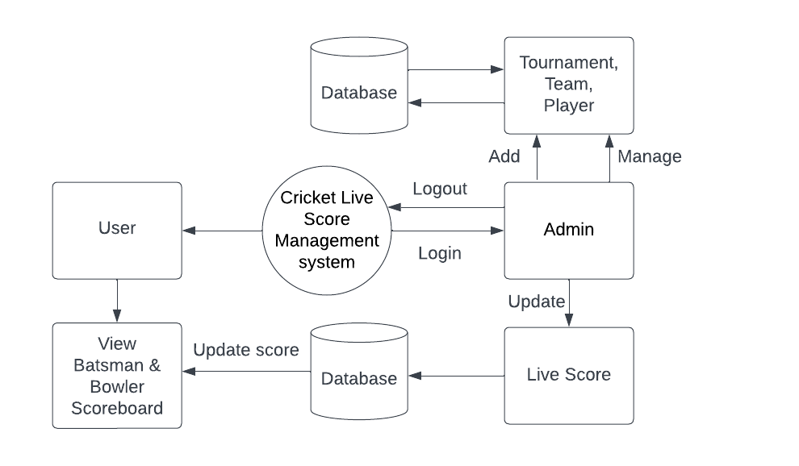

* 1. **DATABASE TABLE**

A database is a separate application that stores a collection of data. Each database has one or more, distinct.

**TOURNAMENT**

|  |  |  |  |
| --- | --- | --- | --- |
| **Column** | **Type** | **Null** | **Default** |
| **Sno** | int(11) | No |  |
| tournament_id | varchar(255) | No |  |
| tournament_name | varchar(255) | No |  |
| start_date | Date | No |  |
| Status | int(11) | No |  |

**TEAM**

|  |  |  |  |
| --- | --- | --- | --- |
| **Column** | **Type** | **Null** | **Default** |
| **Sno** | int(11) | No |  |
| tournament_id | varchar(255) | No |  |
| team_id | varchar(255) | No |  |
| team_name | varchar(255) | No |  |
| short_name | varchar(255) | No |  |
| Status | int(11) | No |  |

**PLAYER**

|  |  |  |  |
| --- | --- | --- | --- |
| **Column** | **Type** | **Null** | **Default** |
| **Sno** | int(11) | No |  |
| team_id | varchar(255) | No |  |
| player_id | varchar(255) | No |  |
| player_name | varchar(255) | No |  |
| Role | varchar(255) | No |  |
| Status | int(255) | No |  |

**SCHEDULE**

|  |  |  |  |
| --- | --- | --- | --- |
| **Column** | **Type** | **Null** | **Default** |
| **Sno** | int(11) | No |  |
| match_id | varchar(255) | No |  |
| Tournament | varchar(255) | No |  |
| team1 | varchar(255) | No |  |
| team2 | varchar(255) | No |  |
| Location | varchar(255) | No |  |
| date&time | Datetime | No |  |
| Status | int(11) | No |  |

**LIVE**

|  |  |  |  |
| --- | --- | --- | --- |
| **Column** | **Type** | **Null** | **Default** |
| **Sno** | int(11) | No |  |
| match_id | varchar(255) | No |  |
| team_id | varchar(255) | No |  |
| Innings | tinyint(4) | No |  |
| Overs | decimal(4,1) | No |  |
| Striker | varchar(255) | No |  |
| Extras | smallint(6) | No |  |
| Total | smallint(6) | No |  |
| Wicket | tinyint(4) | No |  |
| run_rate | decimal(5,2) | No |  |
| req_run_rate | decimal(5,2) | No |  |
| Status | int(11) | No |  |

**ADMIN**

|  |  |  |  |
| --- | --- | --- | --- |
| **Column** | **Type** | **Null** | **Default** |
| **Sno** | int(11) | No |  |
| Id | varchar(255) | No |  |
| Username | varchar(255) | No |  |
| Password | varchar(255) | No |  |

**PROJECT DESCRIPTION**

1. **PROJECT DESCRIPTION**
   1. **OVERVIEW OF THE PROJECT**

The Cricket Score Management System is a web-based application designed to automate the process of recording, managing, and displaying cricket scores. The system will allow users to record scores for different matches, view statistics, and generate reports.

The system will be developed using PHP as the backend programming language and MySQL as the database management system. The system will have two types of users: administrators and regular users. Administrators will have access to all the functionalities of the system, including adding/editing matches, teams, and players, while regular users will only be able to view scores and statistics.

* 1. **MODULE DESCRIPTION**
     1. **User**
        + **View Batsman Score Board -** User can view the Batsman Score Board.
        + **View Bowler Score Board -** User can view the Bowler Score Board.
        + **View Scheduled Matches -** User can view scheduled date and time of the matches.
        + **View Points Table -** User can view the team points in the tournament.
* **View News -** User can view the latest news about cricket.
  + 1. **Admin**
       - **Create Tournament -** Admin will create a tournament.
       - **Create Team -** Admin will create a team of the match.
         * **Team A -** Team A will be the one set of players.
         * **Team B -** Team B will be the opponent of the team A.
* **Create Players -** Admin will create the players in the system.
  + **Assign Role - Bowler, Batsman, Bat & Wk, Allrounder -** The players role will be assigned by the admin as Bowler, Batsman, Bat & Wk, Allrounder.
* **Create Match -** Admin will create the matches in the tournament.
  + **No. of Overs -** Admin can enter the no. of overs for the particular match.
  + **Location -** Admin will enter the location of the match.
  + **Date & Time -** Admin will enter the Date & Time Details of the match.
* **Toss Results -** Admin will update the Toss Results.
  + **Who will won the toss & elected to Bat or Bowl First -** The toss winners and their toss option also be updated.
* **Update Live Score -** Admin will update the live scores of the match.
  + **Strike Batsman - Non-Striker Batsman -** Admin will list the Batsman Order.
    - * **Total Runs - Total Balls - 6s - 4s - Strike rate -** BatsmanScorecards will be updated.
  + **Bowler**
    - **Total overs - Maiden - Run - Wicket - ER -** Bowlers Performance will be updated.
  + **Update Ball by ball runs -** Admin will update score for every ball.
  + **Update -** Admin will do regular update on the website.
    - **No Ball, Wicket -** All extras and changes will be updated.
    - **System will add extra without counting batsman and bowler ball count -** Extras will be updated in the team score but not for the particular player.
* **Update News -** Admin will update the latest news of the match.
  1. **IMPLEMENTATION OF THE PROJECT**

The admin will login using his username and password. If his username and password are correct, then website redirects the administrator dashboard. Administrator will have the all rights of the system, including adding/editing matches, teams, tournaments and players, while regular users will only be able to view scores and statistics.

**SYSTEM IMPLEMENTATION**

1. **SYSTEM IMPLEMENTATION**

Implementation means converting new system design into operation. Thus, the process of implementing the developed system to actual use is called as System Implementation. In this user training is essential for minimizing resistance to change and giving the new system a chance to prove its worth.

Implementation has two other aspects as state below:

* Post Implementation Review.
* Software Maintenance.
  1. **POST IMPLEMENTATION REVIEW**

It is a formal process to determine how well the system is working, how it has been accepted and whether adjustments are needed. It is also important to gather information for the maintenance of the system. A Post implementation’s review measures the system‘s performance against predefined requirements.

* 1. **SOFTWARE MAINTENANCE**

Maintenance is the enigma of system development. maintenance is not as rewarding or exciting as developing systems. It is perceived as requiring neither skill nor experience. Users are not fully cognizant of the maintenance problem or its high cost. Few tools and techniques are available for maintenance.

**TESTING**

1. **TESTING**
   1. **TEST CASE REPORTS**

Testing is a series of different tests that whose primary purpose is to fully exercise the computer-based system. Although each test has a different purpose, all work should verify that all system element has been properly integrated and performed allocated function. Testing is the process of checking whether the developed system works according to the actual requirement and objective of the system.

**Types of Testing:**

* Unit Testing
* Validation Testing
* Output Testing
  + 1. **UNIT TESTING**

All modules were tested and individually as soon as they were completed and were checked for their correct functionality.

* + 1. **VALIDATION TESTING**

At the culmination of the black box testing software is completely assembled as a package. Interface errors have been uncovered and corrected and a final series of test. Validation succeeds when the software function in a manner that can be reasonably accepted by the Customer.

* + 1. **OUTPUT TESTING**

After performing the validation testing the next step is output testing of the proposed system. Since the system cannot be useful if it does not produce the required output. Asking the user about the format in which the system is required tests the output displayed or generated by the system under consideration.

**PERFORMANCE**

1. **PERFORMANCE**
   1. **INTRODUCTION**

Although I have put my best efforts to make the software flexible, easy to operate but limitations cannot be ruled by me. Through the software presents a broad range of options to its users some intricate option could not be covered into, partly because of logistic and partly due to lack of sophistication. Paucity of time was also major constraint; thus, it was not possible to make the software reliable and dynamic. Lack of time also compelled me to ignore some parts.

**FUTURE ENHANCEMENT**

**APPENDIX**

**SAMPLE CODING**

**index.php**

<!DOCTYPE html>

<html lang="en">

<head>

<meta charset="UTF-8">

<meta http-equiv="X-UA-Compatible" content="IE=edge">

<meta name="viewport" content="width=device-width, initial-scale=1.0">

<title>Go Score - Live Cricket Score</title>

<link rel="stylesheet" href="assets/bootstrap/bootstrap.css">

<link rel="stylesheet" href="assets/css/main.css">

<link rel="stylesheet" href="assets/icons/icons.css">

</head>

<body>

<?php

include_once("header.php");

?>

<div class="container-fluid">

<div class="row">

<div class="col-md-4">

<div class="card p-3 my-3">

<div class="d-flex flex-row mb-3">

<div class="d-flex flex-column ml-2">

<span>

<h3>Total No. of Tournaments</h3>

</span>

</div>

</div>

<h2>5</h2>

<div class="d-flex justify-content-end mt-3"><span class="text-primary">View&nbsp;</span></div>

</div>

</div>

<div class="col-md-4">

<div class="card p-3 my-3">

<div class="d-flex flex-row mb-3">

<div class="d-flex flex-column ml-2">

<span>

<h3>Total No. of Teams</h3>

</span>

</div>

</div>

<h2>6</h2>

<div class="d-flex justify-content-end mt-3"><span class="text-primary">View&nbsp;</span></div>

</div>

</div>

<div class="col-md-4">

<div class="card p-3 my-3">

<div class="d-flex flex-row mb-3">

<div class="d-flex flex-column ml-2">

<span>

<h3>Total No. of Players</h3>

</span>

</div>

</div>

<h2>28</h2>

<div class="d-flex justify-content-end mt-3"><span class="text-primary">View&nbsp;</span></div>

</div>

</div>

<div class="col-md-4">

<div class="card p-3 my-3">

<div class="d-flex flex-row mb-3">

<div class="d-flex flex-column ml-2">

<span>

<h3>Today Matches</h3>

</span>

</div>

</div>

<h2>5</h2>

<div class="d-flex justify-content-end mt-3"><span class="text-primary">View&nbsp;</span></div>

</div>

</div>

<div class="col-md-4">

<div class="card p-3 my-3">

<div class="d-flex flex-row mb-3">

<div class="d-flex flex-column ml-2">

<span>

<h3>Recent Winnings</h3>

</span>

</div>

</div>

<h2>India</h2>

<div class="d-flex justify-content-end mt-3"><span class="text-primary">View&nbsp;</span></div>

</div>

</div>

<div class="col-md-4">

<div class="card p-3 my-3">

<div class="d-flex flex-row mb-3">

<div class="d-flex flex-column ml-2">

<span>

<h3>Total Visitors</h3>

</span>

</div>

</div>

<h2>1865</h2>

<div class="d-flex justify-content-end mt-3"><span class="text-primary">&nbsp;</span></div>

</div>

</div>

</div>

</div>

<?php

include_once("footer.php");

?>

<script src="assets/js/main.js"></script>

<script src="assets/js/jquery.min.js"></script>

</body>

</html>

**header.php**

<div class="header">

<header>

<div class="logo">Go Score</div>

<div id="hamburger" class="hamburger"></div>

<nav id="nav-bar" class="nav-bar">

<a href="javascript:void(0)" class="closebtn" onclick="closeNav()">&times;</a>

<ul id="nav-link" class="nav-link">

<li><a href="home.php">Home</a></li>

<li><a href="match.php">Matches</a></li>

<li><a href="#">Points Table</a></li>

<li><a href="news.php">News</a></li>

<li><a href="#footer">Contact Us</a></li>

<li><a href="admin/">Login</a></li>

</ul>

</nav>

</header>

</div>

**footer.php**

<footer id="footer" class="footer">

<div class="container">

<div class="row gy-4">

<div class="col-lg-5 col-md-12 footer-info">

<a href="index.php" class="logo d-flex align-items-center">

<span>Go Score</span>

</a>

<p>Cricket Score Application is about showing lives scores of the cricket match online.Thus user can view cricket scores in real time.</p>

<div class="social-links d-flex mt-4 mb-4">

<a href="#" class="twitter"><i class="bi bi-twitter"></i></a>

<a href="#" class="facebook"><i class="bi bi-facebook"></i></a>

<a href="#" class="instagram"><i class="bi bi-instagram"></i></a>

<a href="#" class="linkedin"><i class="bi bi-linkedin"></i></a>

</div>

</div>

<div class="col-lg-2 col-6 footer-links">

<h4>Useful Links</h4>

<ul>

<li><a href="#">Home</a></li>

<li><a href="#">About us</a></li>

<li><a href="#">Services</a></li>

<li><a href="#">Terms of service</a></li>

<li><a href="#">Privacy policy</a></li>

</ul>

</div>

<div class="col-lg-2 col-6 footer-links">

<h4>Our Services</h4>

<ul>

<li><a href="#">Web Design</a></li>

<li><a href="#">Web Development</a></li>

<li><a href="#">Product Management</a></li>

</ul>

</div>

<div class="col-lg-3 col-md-12 footer-contact text-center">

<h4>Contact Us</h4>

<p>

A108 East Street <br>

Virudhunagar, 626001<br>

Tamilnadu<br>

India <br><br>

<strong>Phone:</strong> +1 5589 55488 55<br>

<strong>Email:</strong> info@example.com<br>

</p>

</div>

</div>

</div>

<div class="container mt-4">

<div class="copyright">

&copy; Copyright <strong><span>Go Score</span></strong>. All Rights Reserved

</div>

</div>

</footer>

**login.php**

<?php

include 'config.php';

session_start();

error_reporting(0);

if (isset($_SESSION['username'])) {

header("Location: index.php");

}

if (isset($_POST['submit'])) {

$uname = trim($_POST['uname']);

$pass = md5($_POST['pass']);

$sql = "SELECT * FROM `admin` WHERE BINARY `username`= BINARY '$uname' AND `password`= '$pass'";

$result = mysqli_query($conn, $sql);

if ($result->num_rows > 0) {

$row = mysqli_fetch_assoc($result);

$_SESSION['id'] = $row['id'];

$_SESSION['username'] = $row['username'];

header("Location: index.php");

} else {

echo "<script>alert('Woops! Email or Password is Wrong.')</script>";

}

}

?>

<!DOCTYPE html>

<html lang="en">

<head>

<meta charset="UTF-8">

<meta http-equiv="X-UA-Compatible" content="IE=edge">

<meta name="viewport" content="width=device-width, initial-scale=1.0">

<title>Log In</title>

<link rel="stylesheet" href="..\assets\css\main.css">

<link rel="stylesheet" href="..\assets\bootstrap\bootstrap.css">

<style>

body {

background-color: #111;

}

.card {

background-color: #212121;

box-shadow: none;

}

.input:focus~label,

input:valid~label {

transform: translateY(-50%) scale(0.8);

background-color: #212121;

padding: 0 .2em;

color: #fefefe;

}

</style>

</head>

<body>

<div class="vh-100 container py-5 h-100">

<div class="row d-flex justify-content-center align-items-center h-100">

<div class="col-12 col-md-8 col-lg-6 col-xl-5">

<div class="card text-white" style="border-radius: 1rem;">

<div class="card-body p-5 text-center">

<form action="" method="POST">

<h2 class="mb-4">Login</h2>

<div class="input-group">

<input type="text" class="input" name="uname" value="<?php echo $uname; ?>" autocomplete="off" required>

<label class="user-label">Username</label>

</div>

<div class="input-group">

<input type="password" class="input" name="pass" value="<?php echo $_POST['pass'] ?>" autocomplete="off" required>

<label class="user-label">Password</label>

</div>

<button class="login-btn" name="submit">Submit</button>

</form>

</div>

</div>

</div>

</div>

</div>

</section>

</body>

</html>

**addplayer.php**

<?php

session_start();

include_once('config.php');

if (!isset($_SESSION['username'])) {

header("Location: login.php");

}

if (isset($_POST['submit']) && $_POST['randcheck'] == $_SESSION['rand']) {

unset($_SESSION['rand']);

$sql = "SELECT `player_id` from player ORDER BY `player_id` DESC LIMIT 1";

$res = mysqli_query($conn, $sql);

if ($res) {

if ($res->num_rows > 0) {

$row = mysqli_fetch_assoc($res);

$player = $row['player_id'];

} else {

$player = "P000";

}

}

$value2 = substr($player, 1);

$value2 = $value2 + 1;

$value2 = sprintf('%03s', $value2);

$player_id = "P" . $value2;

$team_id = $_POST['sel_team'];

$player_name = $_POST['player_name'];

$role = $_POST['sel_role'];

$sql = "INSERT INTO player(`team_id`,`player_id`,`player_name`,`role`) VALUES ('$team_id','$player_id','$player_name','$role') ";

$res = mysqli_query($conn, $sql);

if($res) {

echo "<script>window.location.href=location.href;</script>";

}

}

?>

<!DOCTYPE html>

<html lang="en">

<head>

<meta charset="UTF-8">

<meta http-equiv="X-UA-Compatible" content="IE=edge">

<meta name="viewport" content="width=device-width, initial-scale=1.0">

<title>Go Score - Live Cricket Score</title>

<link rel="stylesheet" href="../assets/bootstrap/bootstrap.css">

<link rel="stylesheet" href="../assets/css/main.css">

<link rel="stylesheet" href="../assets/icons/icons.css">

</head>

<body>

<?php

include_once("header.php");

?>

<div class="container">

<div class="row mt-3">

<div class="flex-wrap">

<div class="col-12">

<button type="button" class="login-btn float-end" data-bs-toggle="modal" data-bs-target="#staticBackdrop" style="width:200px;">Add Player</button>

</div>

</div>

</div>

<div class="row mt-4 mb-4">

<div class="flex-wrap">

<div class="card">

<div class="card-header">

<h2 align="center">Players</h2>

</div>

<div class="card-body">

<?php

$sql = "SELECT * from team WHERE `status`= 0";

$res = mysqli_query($conn, $sql);

while ($row = mysqli_fetch_assoc($res)) {

$t_id = $row['team_id'];

?>

<div class="card mb-4">

<div class="card-header">

<div class="row">

<div class="col-7">

<?php

$sql1 = "SELECT * from tournament WHERE `tournament_id`='" . $row['tournament_id'] . "' AND `status`= 0";

$res1 = mysqli_query($conn, $sql1);

if ($row1 = mysqli_fetch_assoc($res1)) {

echo "<h6>" . $row1['tournament_name'] . "</h6>";

}

?>

</div>

<div class="col-5">

<h6>No. of Players</h6>

</div>

</div>

</div>

<div class="card-body">

<div class="row">

<div class="col-7">

<?php echo $row['team_name']; ?>

</div>

<div class="col-5">

<?php

$sql2 = "SELECT COUNT(`player_id`) AS total FROM `player` WHERE `team_id`='$t_id'";

$res2 = mysqli_query($conn, $sql2);

$row2 = mysqli_fetch_assoc($res2);

echo $row2['total'];

?>

</div>

</div>

</div>

<div class="card-footer mx-2">

<a href="" onclick="openModal('<?php echo $t_id; ?>');" data-bs-toggle="modal" id="openModal">View Players</a>

</div>

</div>

<?php } ?>

</div>

</div>

</div>

</div>

<!-- Modal -->

<div class="modal fade" id="staticBackdrop" data-bs-backdrop="static" data-bs-keyboard="false" tabindex="-1" aria-labelledby="staticBackdropLabel" aria-hidden="true">

<div class="modal-dialog modal-dialog-centered">

<div class="modal-content">

<div class="modal-header">

<h5 class="modal-title" id="staticBackdropLabel">Add Player</h5>

<button type="button" class="btn-close" data-bs-dismiss="modal" aria-label="Close"></button>

</div>

<form action="" method="post">

<div class="modal-body">

<div class="row mx-3 mb-2">

<div class="form-group">

<label for="sel_tour" class="form-label">Select Tournament :</label>

<select name="sel_tour" id="sel_tour" class="form-select" onchange="tour_id(this.value);" required>

<option value="">- - SELECT - -</option>

<?php

$sql = "SELECT * from tournament WHERE `status`= 0";

$res = mysqli_query($conn, $sql);

while ($row = mysqli_fetch_assoc($res)) {

?>

<option value="<?php echo $row['tournament_id'] ?>"><?php echo $row['tournament_name'] ?></option>

<?php } ?>

</select>

</div>

</div>

<div class="row mx-3 mb-2">

<div class="form-group">

<label for="sel_team" class="form-label">Select Team :</label>

<select name="sel_team" id="sel_team" class="form-select" required>

<option value="">- - SELECT - -</option>

</select>

</div>

</div>

<div class="row mx-3 mb-2">

<div class="form-group">

<label for="player_name" class="form-label">Player Name :</label>

<input type="text" class="form-control" id="player_name" name="player_name" placeholder="Enter Player Name" required>

</div>

</div>

<div class="row mx-3 mb-2">

<div class="form-group">

<label for="sel_role" class="form-label">Select Role :</label>

<select name="sel_role" id="sel_role" class="form-select" required>

<option value="">- - SELECT - -</option>

<option value="Batsman">Batsman</option>

<option value="Bowler">Bowler</option>

<option value="Allrounder">Allrounder</option>

<option value="Bat & Wkt">Bat & Wkt</option>

<option value="Allrounder (C)">Allrounder (C)</option>

<option value="Bat & Wkt (C)">Bat & Wkt (C)</option>

</select>

</div>

</div>

</div>

<div class="modal-footer">

<button type="button" class="btn btn-secondary" data-bs-dismiss="modal">Close</button>

<button type="submit" name="submit" class="btn btn-primary">Create</button>

</div>

</form>

</div>

</div>

</div>

<div id="view-players"></div>

</div>

<script src="../assets/js/main.js"></script>

<script src="../assets/js/jquery.min.js"></script>

<script src="../assets/bootstrap/bootstrap.bundle.min.js"></script>

</body>

</html>

**SCREEN DESIGN**

**User Page**

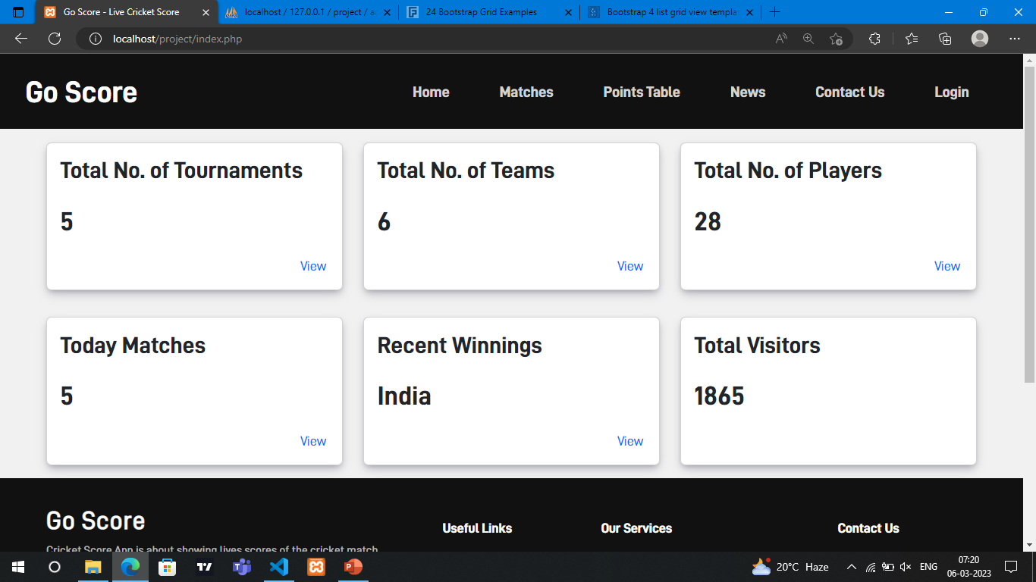

**Login Page**

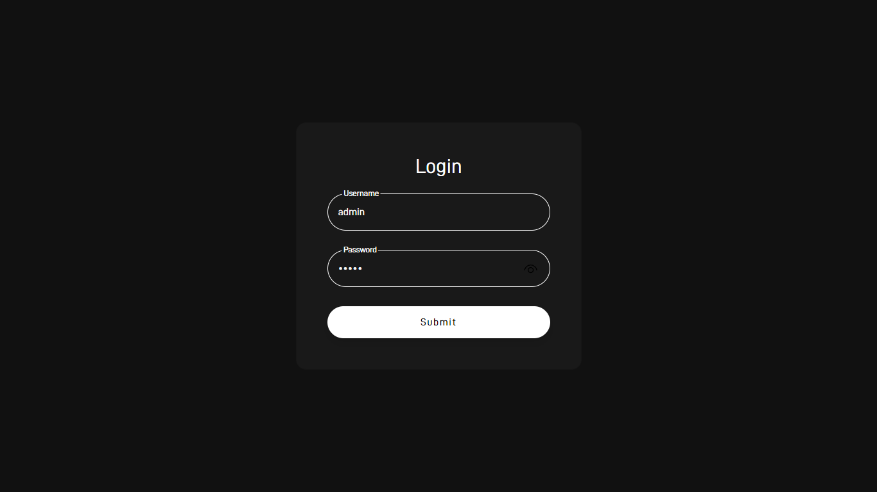

**Admin Dashboard**

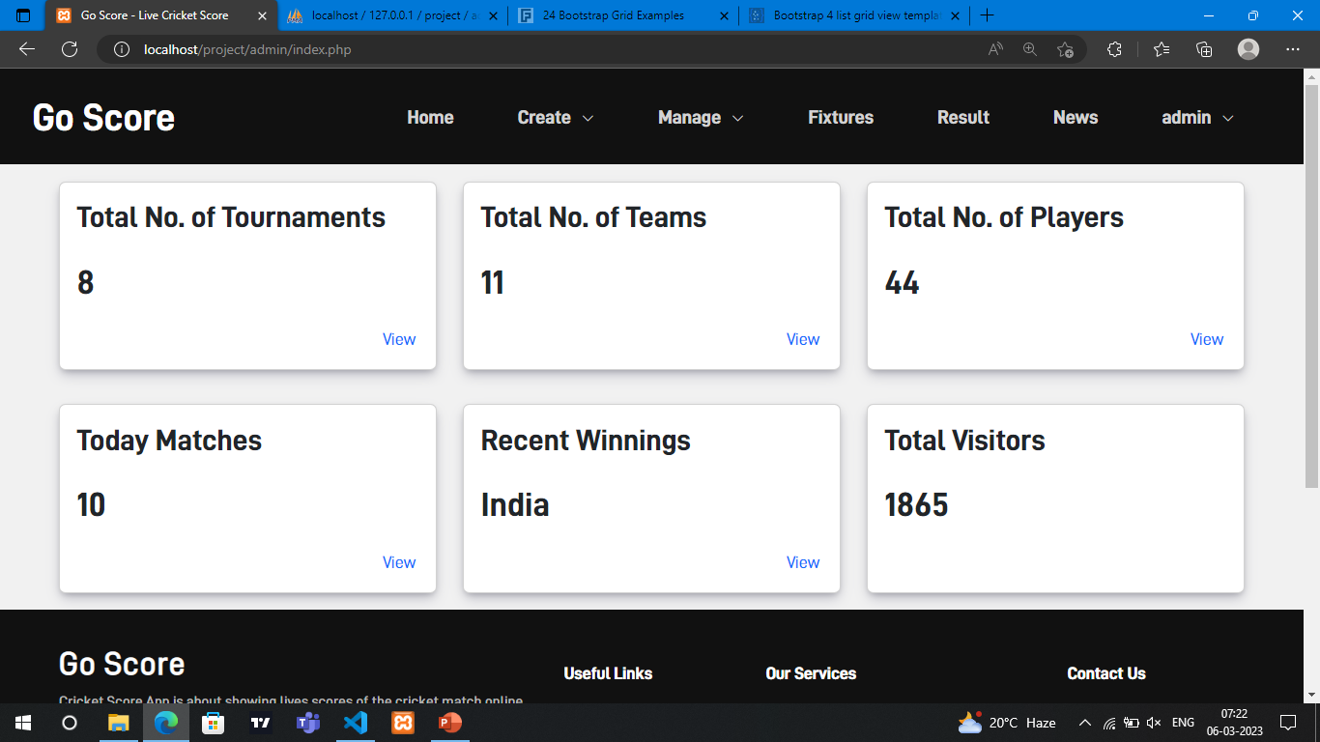

**Tournament Creation**

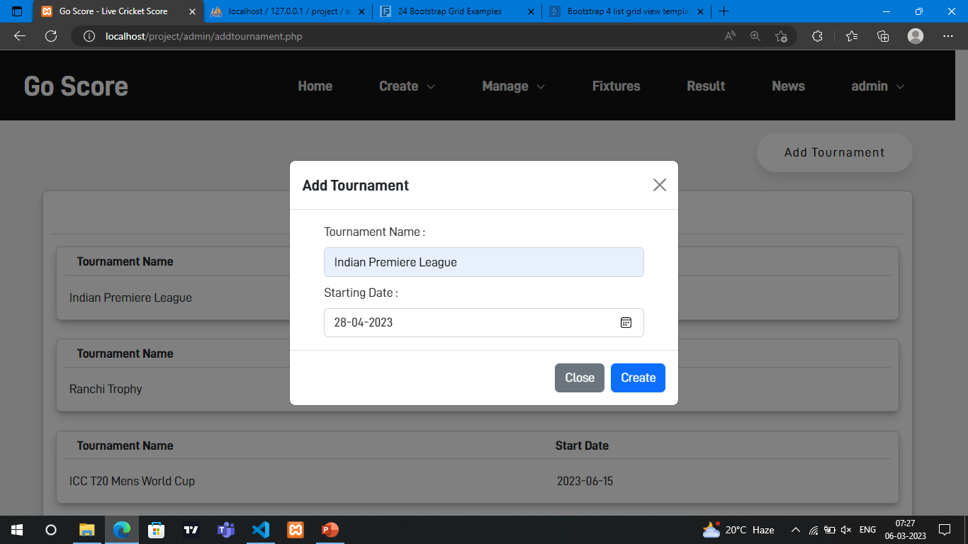

**Team Creation**

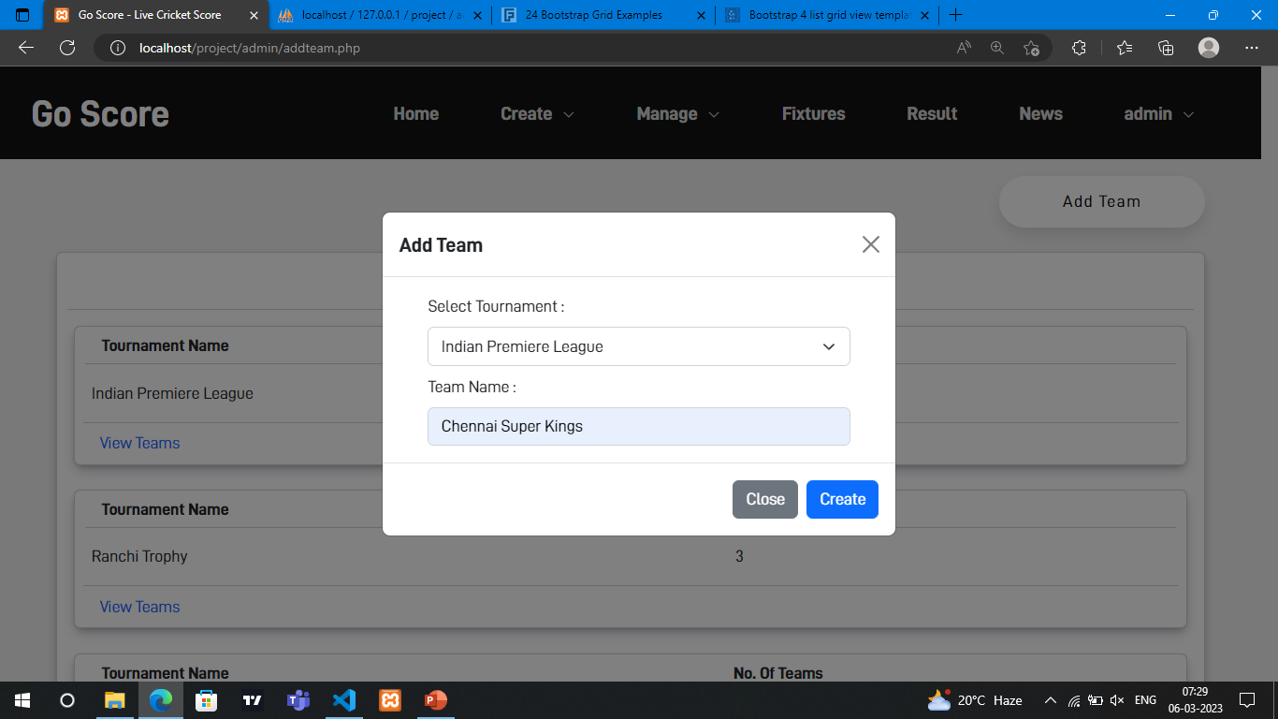

**Player Creation**

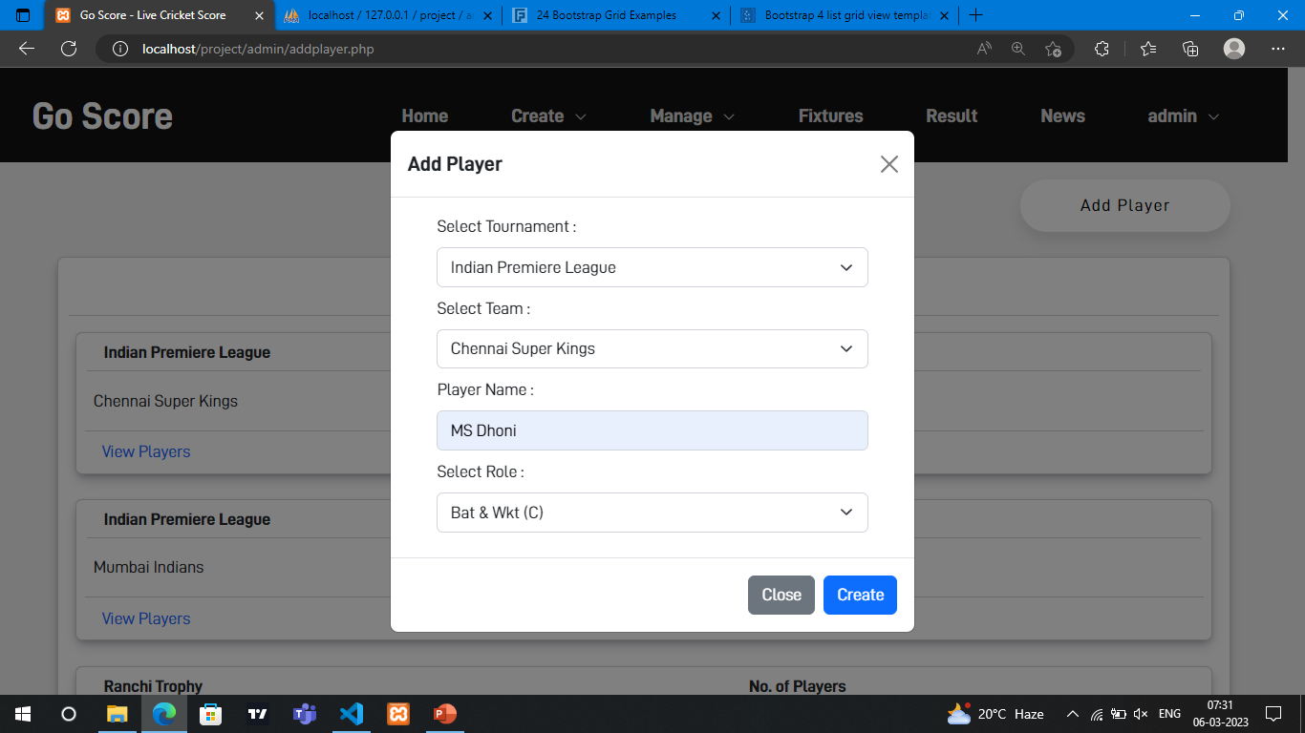

**Manage Tournaments**

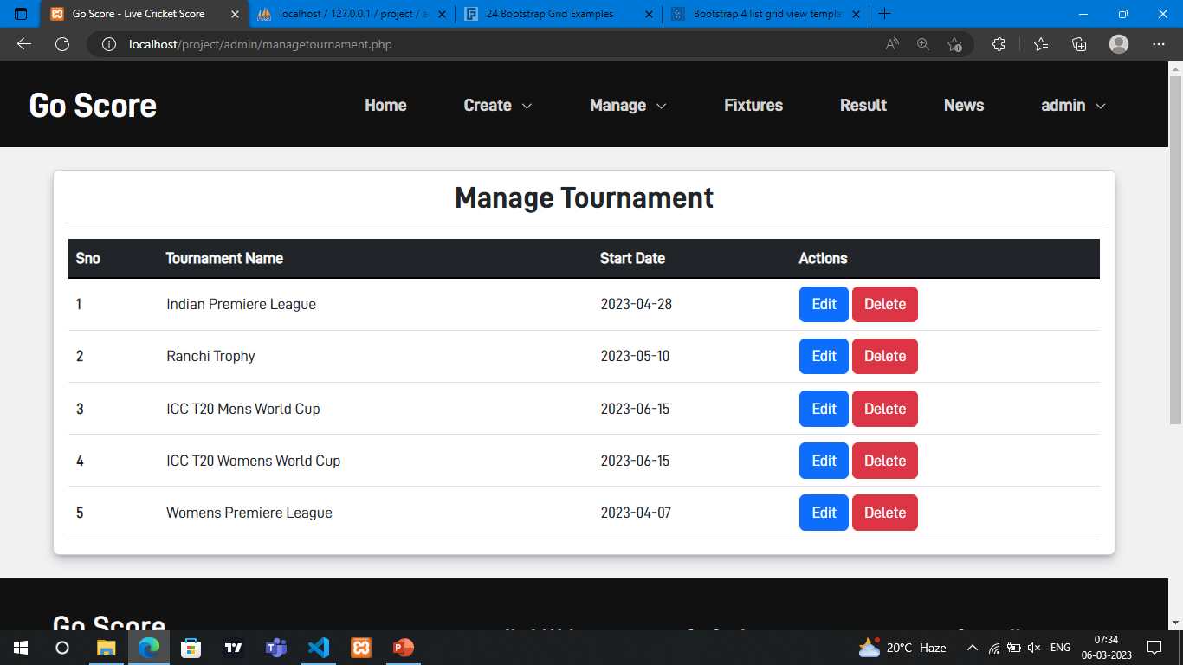

**Edit Records**

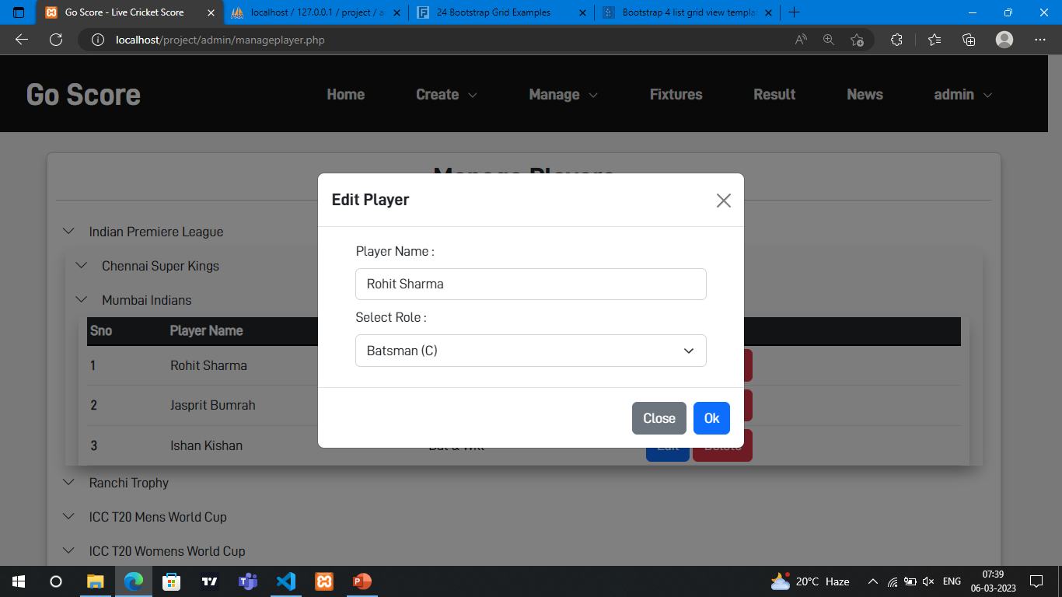

**Toss Decision**

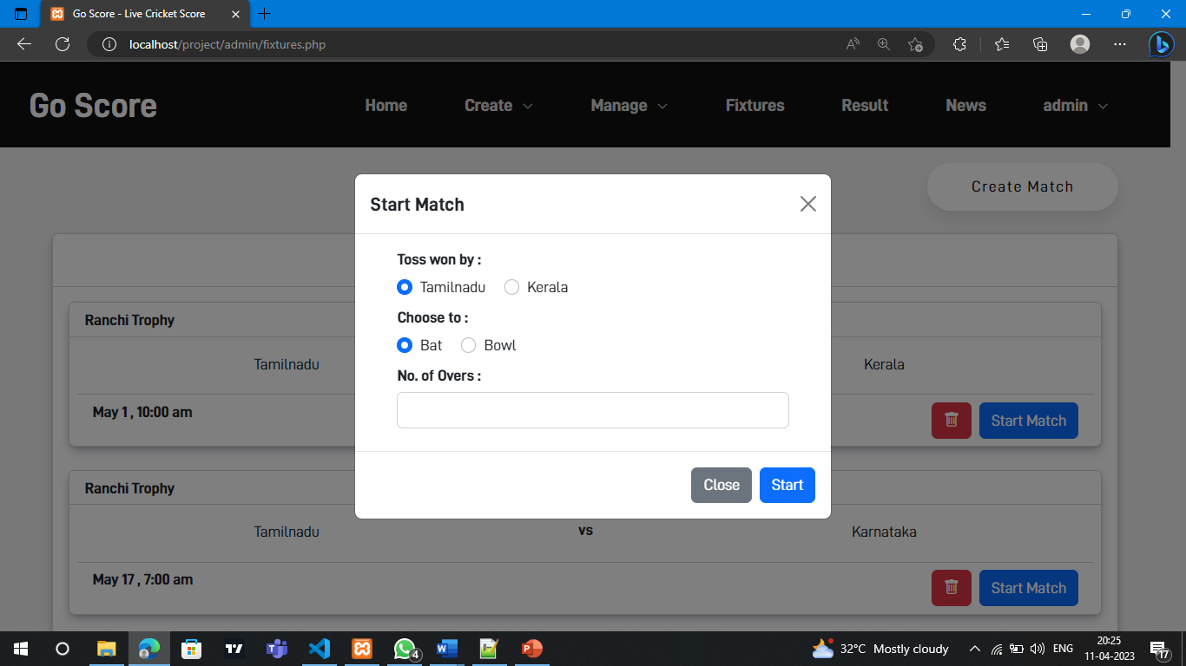

**Update Score**

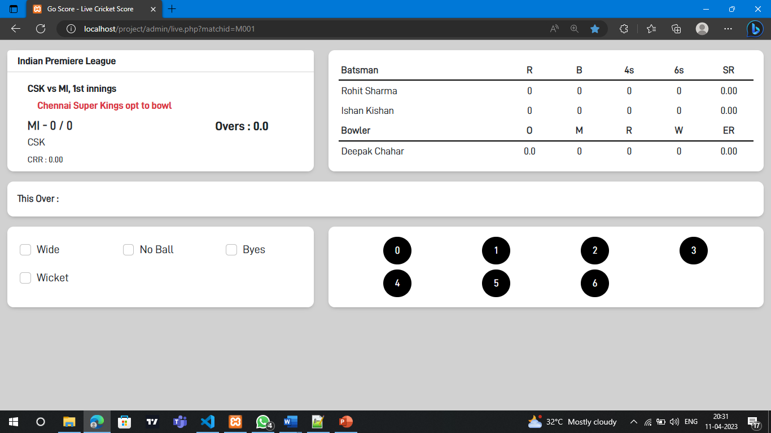

**Add News**

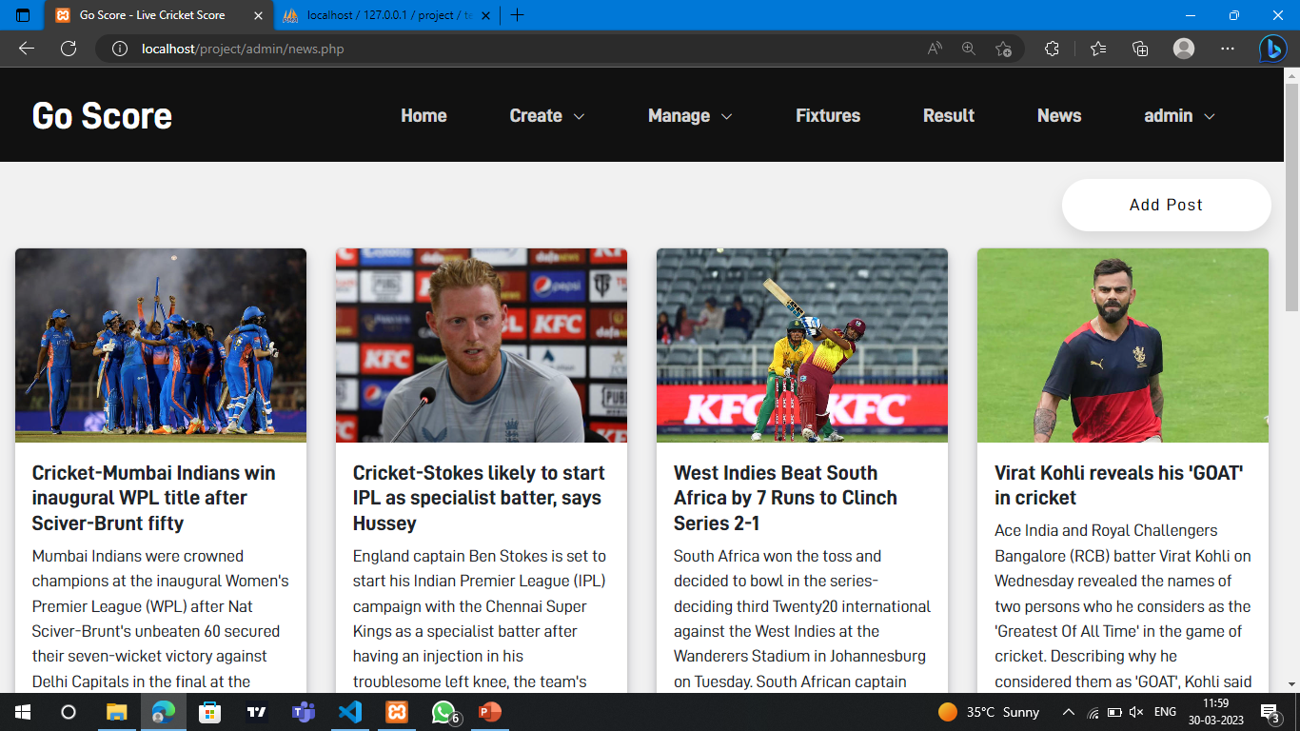

**Change Password**

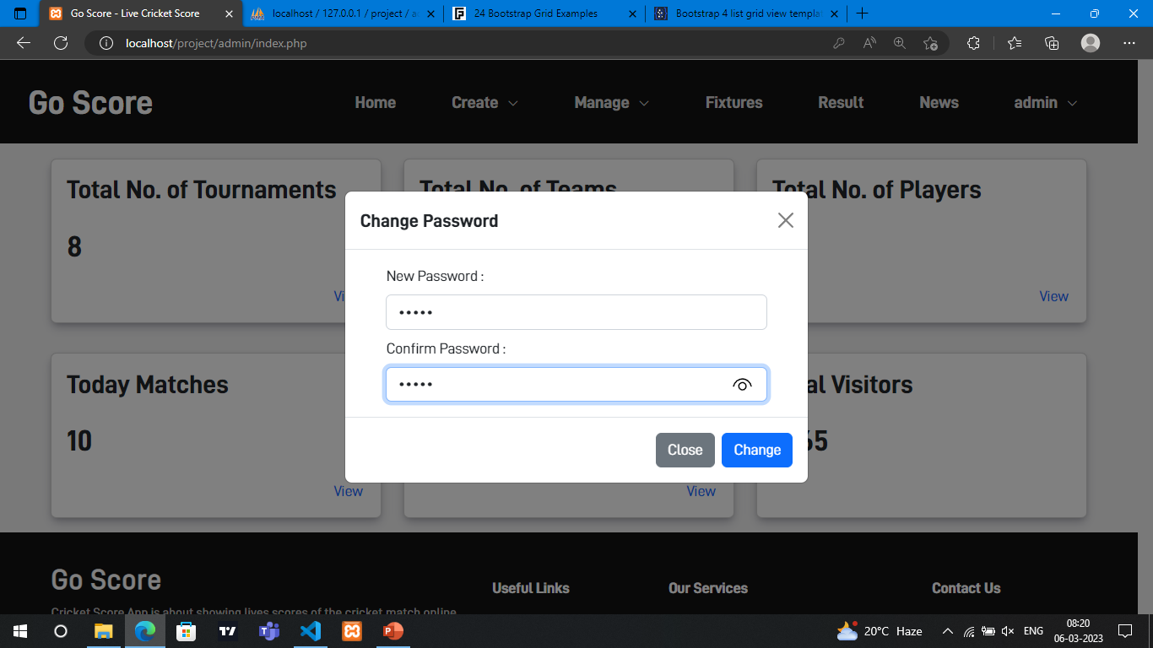

**BIBLIOGRAPHY**

**REFERENCE:**

Larry Ullman – PHP 6 MySQL 5 FOR DYNAMIC WEBSITES

**WEBSITE REFERENCE:**

* https://w3schools.com – For References
* https://getbootstrap.com - For Bootstrap Classes